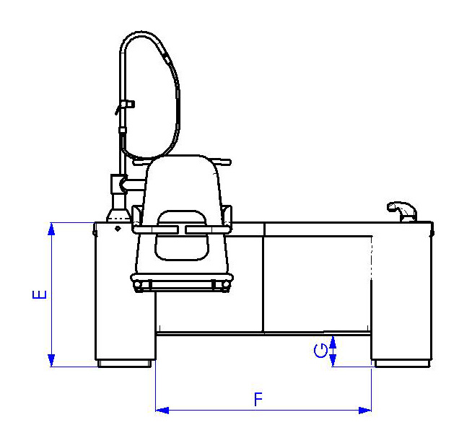
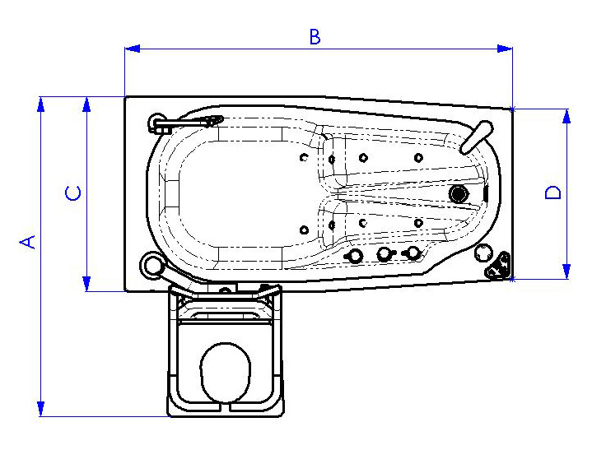
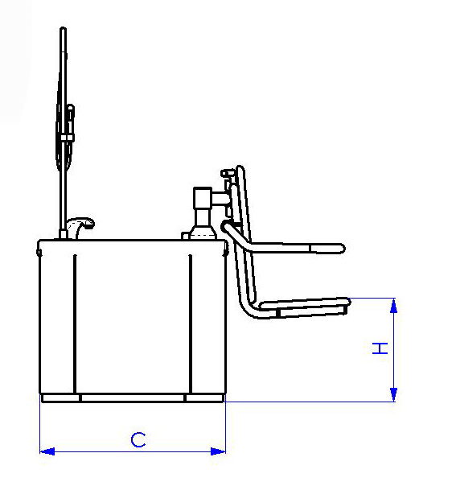
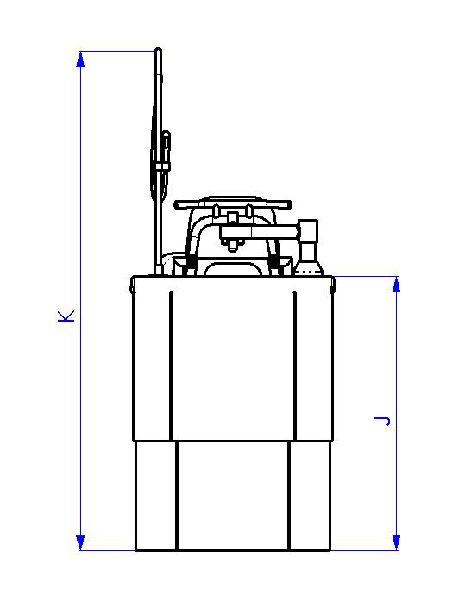
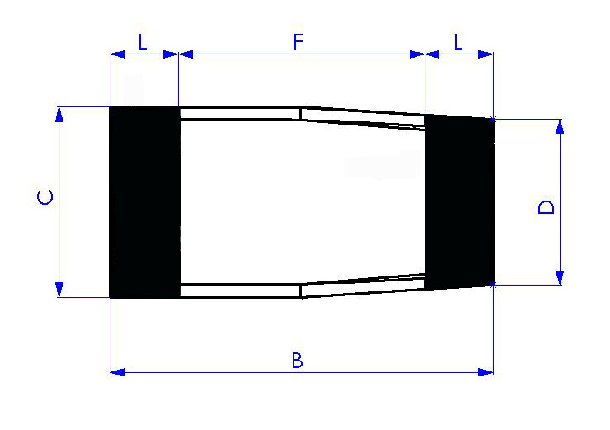
A = 1323mm (52 1/8”)
B = 1600mm (63” )
C = 800mm (31 1/2”)
D = 700mm (27 1/2”)
E = 685mm (27” )
F = 1020mm (40 1/8”)
G = 150mm (6” )
H = 440mm (17 1/4”)
J = 1085mm (42 3/4”)
K = 1985mm (78 1/8”)
B = 1600mm (63” )
C = 800mm (31 1/2”)
D = 700mm (27 1/2”)
F = 1020mm (40 1/8”)
L = 290mm (11 3/8”)

